Guest blog: Afterschool robotics, down under 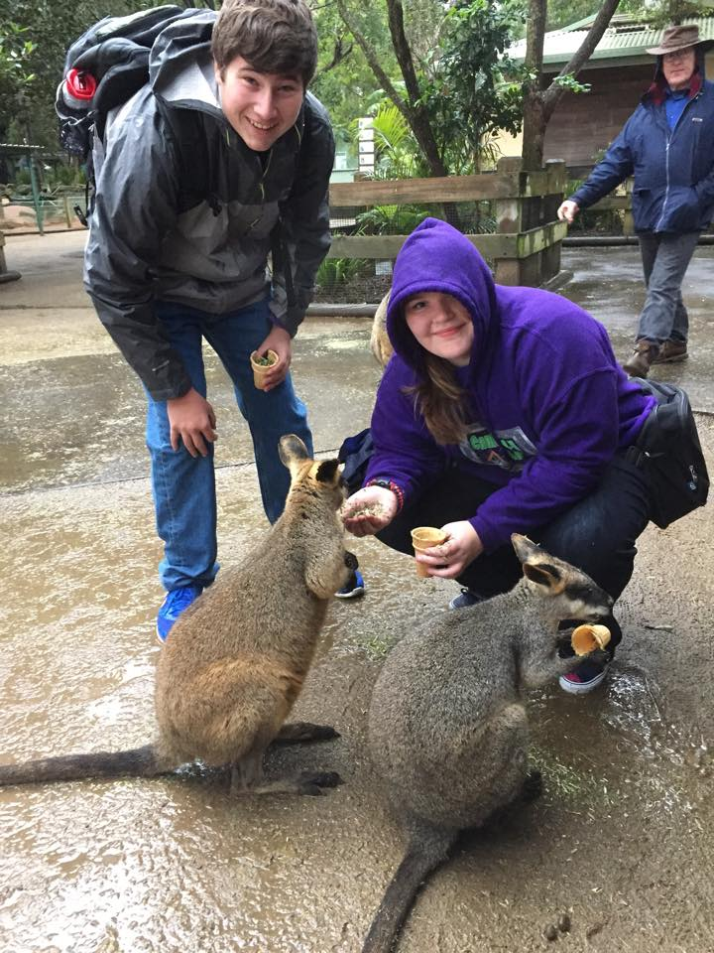
9 13 15
By Rachel Clark/Sherry Comer
Photo via Camdenton 4-H FIRST® LASER 3284 Robotics.
Sherry Comer is an Afterschool Ambassador Emeritus and Director of Afterschool Services in Camdenton, Missouri.
It was a “g’day” for the Camdenton R-III Afterschool Services department when they were notified that one of their five FIRST® Tech Challenge (FTC) robotics teams had been selected to be the Missouri FTC team representing FIRST® Robotics at an international level at the Asia Pacific tournament in Sydney, Australia, in July. Their selection was even more special because this small group of students was made up of 7th and 8th graders, even though most FTC teams are made up of 9-12th graders.
Camdenton is located in central Missouri in the heart of Lake of the Ozarks. This small town of 3,200 is tucked away in the hills where little industry exists and the economy relies heavily on tourism dollars earned in the summer to survive the winter months. The Camdenton R-III School system covers a massive area of 372 square miles. Bus rides to and from school can be more than 45 minutes one way. Camdenton founded an afterschool program 16 years ago after being awarded a federal 21st CCLC grant. The program has grown significantly over the years and now serves almost a quarter of the 4,200 K-12 student population through its innovative afterschool programs. About 7 percent of our afterschool children participate on one of the LASER (Laker Afterschool Science Engineering and Robotics) FIRST® teams in grades 2-12.
As the Director of Afterschool Services, I was thrilled that students were able to experience new cultures, and that they worked hard to figure out how to communicate with international teams whose members didn’t speak English, so that they could work in alliances to compete. It was definitely a culture shock for the majority of our students. Several of them had never flown and only one had traveled outside the United States. Students had to quickly adapt to learn to exchange money, to walk on the opposite side of the sidewalk, and to find ways to communicate. They quickly realized food looks and tastes different around the world.
Under the tournament’s rules, at the end of the quarter-final round, top-ranked teams invite other teams to join in alliances, which then go on to compete in the final rounds. After seeing our LASER 5908 team perform, both the top- and second-ranked teams (Cougar Robotics from Columbus, Ohio, and Wingus Dingus from New Zealand) asked our kids to join them. Our kids accepted the alliance invitation, and went on to form a tournament-winning alliance.
The students were very excited to bring home the top honor from the tournament, but they were most proud that they were honored with the Motivate Award, which celebrates the team that exemplifies the essence of the FIRST® Tech Challenge competition through teambuilding, team spirit, and exhibited enthusiasm. This team embraces the culture of FIRST® and clearly demonstrates what it means to be a team. This is a team that makes a collective effort to make FIRST® known throughout their school and community, and that sparks others to embrace the culture of FIRST®.
Taylor McGowan never dreamed that when she signed up to be on the afterschool robotics team that it would take her literally around the world. As a seventh-grader, Taylor had never flown, let alone traveled outside of Missouri. “I can’t believe I got to travel to Australia, meet kids from other countries, and pet kangaroos and koalas! Being on the winning alliance team and representing our school and community by bringing home the ‘Motivate Award’ meant a lot to us! We took our responsibility of representing ourselves, our community, our state, our country and FIRST® robotics seriously. This trip was a once-in-a-lifetime experience for me, and it has changed the way I view the world!”
“Throughout our FIRST® robotics progressions of programs we have worked diligently to better our community, to grow and share FIRST® at a local, state, national and even international level,” said head LASER FTC Coach Christine Head. “We are fortunate that our administrators and school board see the value of offering a high quality STEM program like FIRST® robotics to our students through the afterschool setting.”

