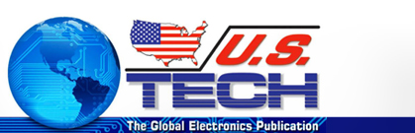

Nihon Superior to Sponsor FIRST Robotics Competition at SMTAI
OSAKA, JAPAN — Nihon Superior Co. Ltd., a supplier of advanced soldering materials to the global market, will sponsor the FIRST Robotics competition at the upcoming SMTA International Exhibition, scheduled to take place October 15-16, 2013 at the Fort Worth Convention Center in Texas. After a successful event at the SMTA Atlanta Chapter Expo, SMTA is bringing the competition to an international audience.
Dubbed a varsity Sport for the Mind™, FRC combines the excitement of sport with the rigors of science and technology. Under strict rules, limited resources and time limits, teams of 25 students or more are challenged to raise funds, design a team “brand,” hone teamwork skills, and build and program a robot to perform prescribed tasks against a field of competitors. Tetsuro Nishimura, Nihon Superior President, remarked, “Nihon Superior has been a proud sponsor of the 2013 World Galileo Finalist Camdenton 4-H FIRST LASER 3284 team and is pleased to sponsor this competition at SMTAI so that attendees can see the talents of future scientists and engineers. In addition, the matches are quite exciting to watch.”
FIRST Robotics’ mission is to inspire young people to be science and technology leaders, by engaging them in exciting mentor-based programs that build science, engineering and technology skills, that inspire innovation and that foster well-rounded life capabilities including self-confidence, communication and leadership. For more information about FIRST Robotics and LASER 3284, please visit http://www.usfirst.org and http://www.laser3284.org.

