Camdenton LASER team gives back to community during holiday season

Posted Dec 24, 2019 at 6:00 AM

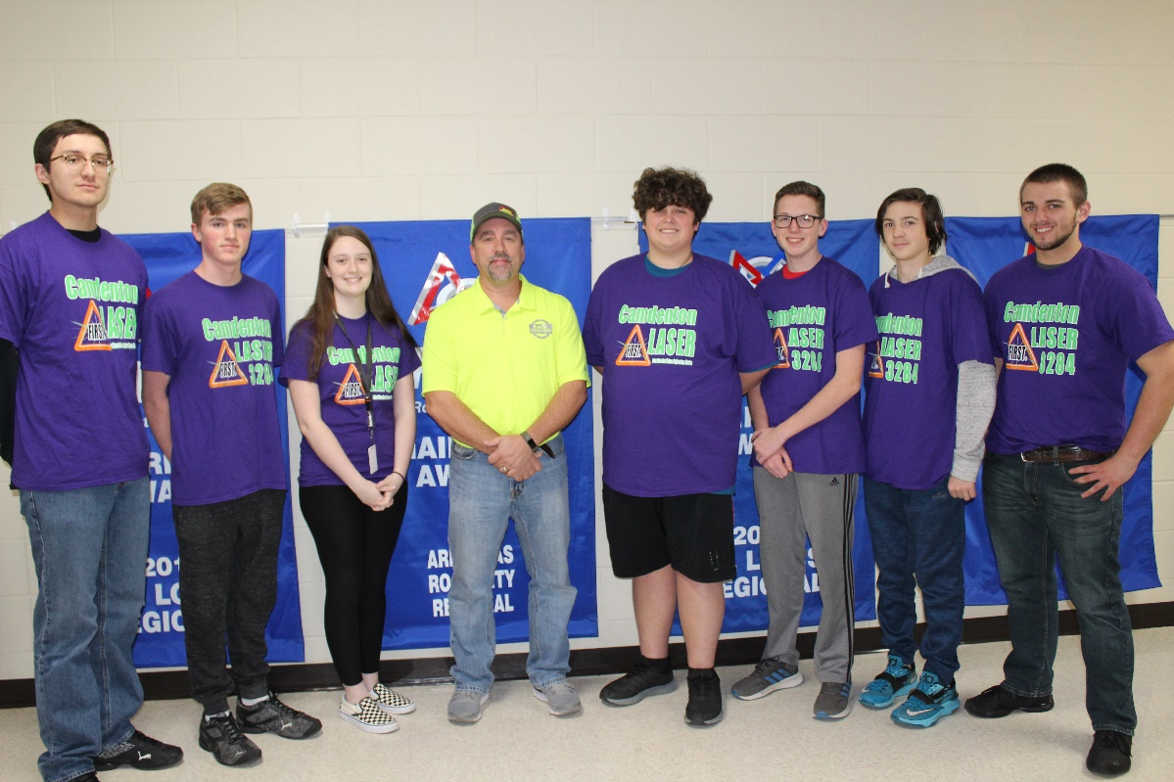

The Camdenton LASER teams felt blessed this holiday season to receive a message from John Rooks, the owner of Border Xpressions. LASER robotics put a quick post on their Facebook page to let the community know that they only had ten trees left at the Christmas tree lot.
The Camdenton LASER teams felt blessed this holiday season to receive a message from John Rooks, the owner of Border Xpressions. LASER robotics put a quick post on their Facebook page to let the community know that they only had ten trees left at the Christmas tree lot. In less than thirty minutes, the team received a message to contact Mr. Rooks, as he was interested in buying the remainder of the trees at the Optimist/LASER lot.
LASER robotics quickly contacted Mr. Rooks and he said he would like to purchase the remaining trees as long as the team would make sure families got Christmas trees that might not have one. The LASER team donated the trees to the Osage Hills Church mobile food pantry. Families that did not have a tree were able to take one home with them when they picked up food for the holidays.
Mr. Rooks stated it was a win for him, he was able to help needy families and he was supporting FIRST robotics. It turns out that Mr. Rooks’ company is located in Sedalia and he had mentored robotics for Sedalia’s FIRST robotics team. LASER has numerous connections with Sedalia’s Team Scream as their assistant coach; Ashely Beard Hiza is an alumnus from Camdenton LASER 3284 and LASER mentored Team Scream in their inaugural season.′
The Camdenton LASER program would like to thank Border Xpressions for their generosity. An additional thank you goes to the Camdenton Optimist Club for allowing the LASER Robotics teams the opportunity to run their lot and to the Optimists for donating 100% of the profits to the LASER teams to offset travel and competition costs.

