The Lake News Online
April 3, 2019
The Chairman’s honor is awarded to team that reflects sustained excellence and impact within the FIRST community.
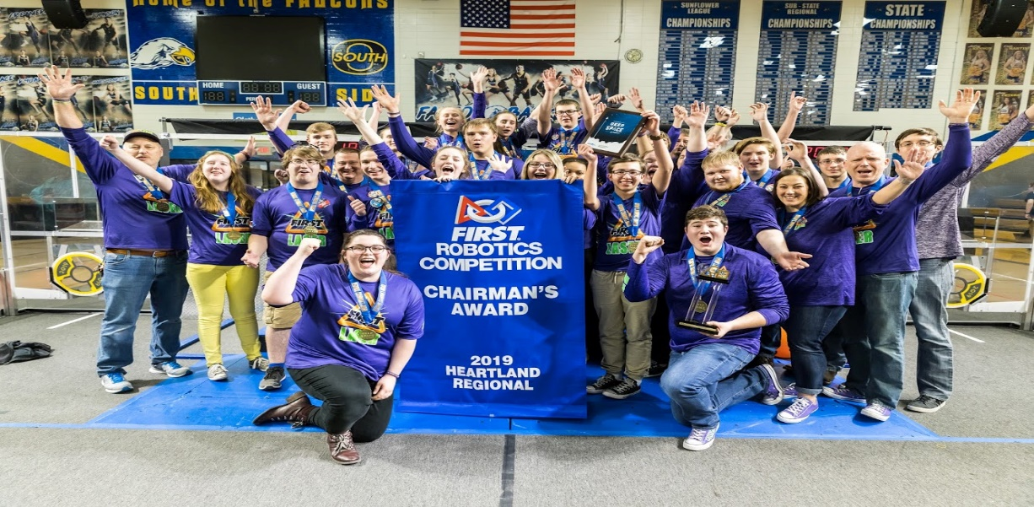
The last two weeks have been busy for the Camdenton FIRST LASER 3284 High School robotics team and they are gearing up for their third regional and their ninth trip to the World Championship in the team’s ten-year history!
The LASER team traveled to Kansas City two weekends in a row to compete in the Heartland and Greater Kansas City Regionals and saw much success. The build season this year was a tough one with snow and ice often keeping the bulk of the team from meeting to design, fabricate, wire, program and build a 125 pound competition robot that delivers cargo and hatches to a “planet” in the 2019 FRC competition, Destination Deep Space, presented by Boeing. The first Saturday in January part of the team traveled to Kansas City to attend a local FIRST FRC kickoff, seniors traveled to New Hampshire to attend the national kickoff and attend a reception at Dean Kamen’s home (the founder of FIRST and famous inventor) and to tour his research company DEKA.
After returning to Camdenton team members read the game manuals that include rules and restrictions as to what you can build and how you can operate your robot at competitions. They also memorized the rules of this year challenge. The work began and students stayed every night after school, seven days a week to produce not only a competition robot that has to be “bagged and tagged” or sealed after six week period, but also they built a practice robot to learn to drive and prepare for competitions. In addition to building, the robot students also worked on graphics, videos, presentations, programming, 3D modeling-CAD, 3D printing, welding and machining.
All the hard work dedication and perseverance paid off as students won Chairman’s, the most prestigious award FIRST honors teams with! The Chairman’s honor is awarded to team that reflects sustained excellence and impact within the FIRST community, in its own community and beyond.
This award includes an essay, a seven-minute presentation with a question session and a video submission describing the teams role, outreach, mentoring and promotion of FIRST and STEM at a local, state, national and international level. This award automatically qualifies the team to attend the World Championship in Houston next month. This is the sixth consecutive Chairman’s banner the team has earned and puts them in contention for the World Championship Hall of Fame.
LASER team member, Maya Irvine, nominated for the prestigious Dean’s List by the LASER team’s mentors was chose by judges at the Heartland regional to represent and compete at the World Championship for the international Dean’s List. She will compete to become one of ten worldwide Dean’s List Winners. LASER had a Championship Dean’s List winner, Brenden Barbour, in 2016. The Dean’s List students are examples of student leaders who have led their teams and communities to increase awareness for FIRST and its missions all the while achieving personal expertise and accomplishments. Maya was one of five National Afterschool Youth Ambassadors in the United States in 2018 and presented FIRST on Capitol Hill, in Washington DC, to members of Congress and Afterschool professionals.
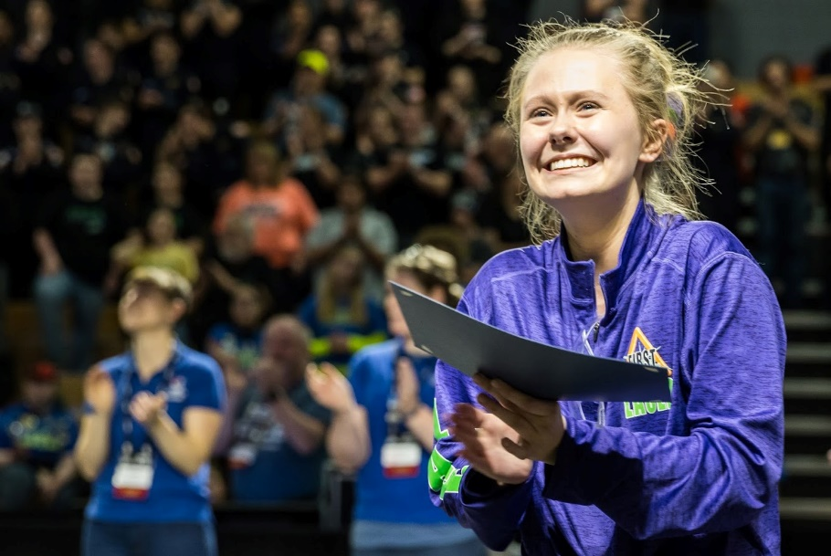

The Greater Kansas City regional saw a much improved robot, Decennium, battle through the qualifier tournament matches to move on to quarter finals, semis and to compete for the Championship. The robot proved to be worthy opponent, ranked #4, when alliance selections occurred with a 10-2 record. LASER was invited, by the number one alliance, to join them to compete in quarterfinals. The alliances of Team Titanium 1986 from Lees Summit West, LASER 3284 and S.W.A.T. 1806 from Smithville put up a tough fight, falling in the Championship match by four points. It was a battle for the crown until the final seconds. LASER brought home a Finalist trophy and medals.
LASER’s safety team continued its tradition by capturing their thirteenth Underwriter’s Laboratory Safety Award.The team hopes to capture the World Championship Divisional Crown for the third time in April. One hundred percent of the team is CPR certified and Equity, Diversity and Inclusion Certified. In addition, several team members became certified Youth Mental Health Helpers. The safety captains help instill safety as a value that the team embraces as they work all year. UL Safety is awarded to teams that demonstrate safety throughout their programs and are committed to developing and nurturing a safety culture in FIRST and their community.
In addition, the team brought home the Engineering Excellence award. This award celebrates an elegant and advantageous machine feature. LASER 3284′s robot, Decennium, was designed by students to use vision to collect cargo and hatches in a quick manner using an 8-wheel tank drive with dual speed and shifting gearboxes.
Each regional selects one mentor as the Woodie Flowers Finalist that has been nominated by students who submit an essay. This year LASER Coach, Sherry Comer, was named as an outstanding mentor in the robotics competition who best leads, inspires and empowers their team. One winner will be announced at the World Championship. Previous Woodie Flowers Finalists presented the trophy and banner to Coach Comer. It was a special moment with previous winner, Mitch Comer (LASER head coach) presented the award to is wife with other previous Finalist nominees from the region.

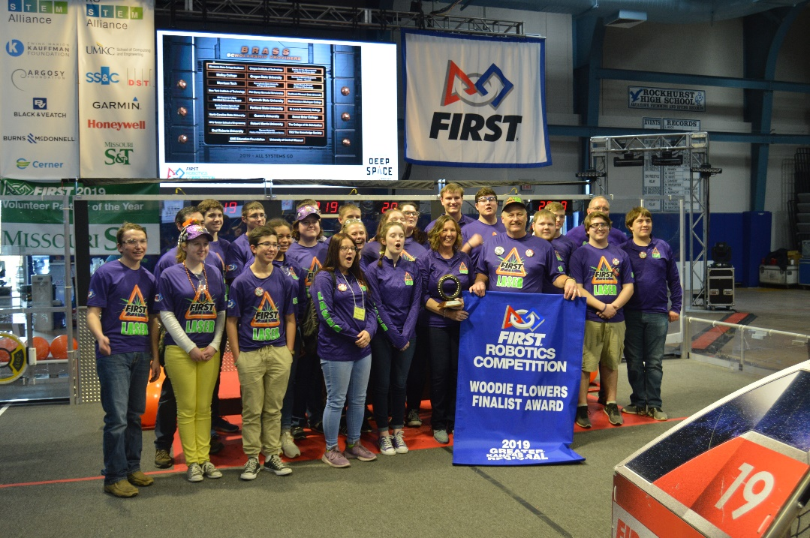
LASER will compete in Sedalia at Smith Cotton High School April 5, 6 and 7th. LASER hopes the community will make the trip to see the tournament and what all the excitement is all about as this will be the closest FIRST FRC high school competition this year in our region.
If you would like sponsorship information or would like to learn more about FIRST LASER robotics please visit www.laser3284.org.

